

Project Proposal

**Project:** Cymed – Online Medical Service Providing System

**Group:** 07

**Course:** CSE482L – Internet and Web Technology Lab

**Section:** 02

**Course Instructor:** Md. Naqib Imtiaz Hussain (NQH)

**Lab Instructor:** Farjana Alam

**Submission Date:** 13 June 2022

|  |  |  |
| --- | --- | --- |
| Name | ID | Email |
| Mohammad Nabiluzzaman Neloy | 1831251042 | [mohammad.nabiluzzaman@northsouth.edu](mailto:mohammad.nabiluzzaman@northsouth.edu) |
| Rafid Ahmed | 1831395642 | [rafid.ahmed@northsouth.edu](mailto:rafid.ahmed@northsouth.edu) |

*Table of Contents*

*1. Abstract ………………………………………………………………………………………………………………………….. 4*

*2. Introduction ……………………………………………………………………………………………………………………. 4*

*3. Background and Product Context ……………………………………………………………………………………. 4*

*4. Use-Cases (Patient’s Panel) …………………………………………………………………………………………….. 5*

*4.1 Registration ……………………………………………………………………………………………………… 5*

*4.2 Login ………………………………………………………………………………………………………………… 5*

*4.3 Make Appointment ………………………………………………………………………………………….. 5*

*4.4 Check Prescriptions ………………………………………………………………………………………….. 6*

*4.5 Check Vaccination Records ……………………………………………………………………………….. 6*

*4.6 Buy Drugs from Drug Shop ………………………………………………………………………………. 6*

*5. Use-Cases (Doctor’s Panel) …………………………………………………………………………………………….. 6*

*5.1 Login ………………………………………………………………………………………………………………… 7*

*5.2 Check Appointments Queue …………………………………………………………………………….. 7*

*5.3 Generate Prescription (Normal) ……………………………………………………………………….. 7*

*5.4 Generate Prescription (Vaccination) …………………………………………………………………. 7*

*5.5 Select Required Drug(s) …………………………………………………………………………………… 7*

*6. Use-Cases (Admin’s Panel) ……………………………………………………………………………………………. 8*

*6.1 Registration …………………………………………………………………………………………………….. 8*

*6.2 Login ……………………………………………………………………………………………………………….. 8*

*6.3 Add New Doctor ………………………………………………………………………………………………. 8*

*6.4 Remove Doctor ……………………………………………………………………………………………….. 9*

*6.5 Add New Drug …………………………………………………………………………………………………. 9*

*6.6 Remove Drug …………………………………………………………………………………………………… 9*

*6.7 Edit Drug Stock Availability ……………………………………………………………………………… 9*

*7. Software ……………………………………………………………………………………………………………………..… 9*

*8. Technologies ………………………………………………………………………………………………………………... 10*

*9. Front-End Plan ……………………………………………………………………………………………………………… 10*

*10. Back-End Plan …………………………………………………………………………………………………………… 10*

*11. Development Plan ……………………………………………………………………………………………………. 11*

*12. Project Schedule (Gantt Chart) ………………………………………………………………………………… 12*

1. Abstract

Medical facilities have been developing daily, and the necessity of providing the best possible medical care to the customers has been the primary goal for most health care facilities. In the modern world of the Internet, it is still observed that many medical care facilities provide handwritten prescriptions, and printed vaccine certifications. This creates a hustle in keeping up the lifetime medical records of a patient in one single place and also increases paperwork. Cymed is an online medical service providing a platform where doctors can provide digital prescriptions to their customers, and select available drugs to be prescribed for their patients. Additionally, it also provides the facility for a patient to make an appointment with a doctor, check vaccination history, and much more.

2. Introduction

Cymed is a medical service providing, web-application, that facilitates the process of scheduling appointments, generating online prescriptions, keeping lifetime vaccination records, and purchasing prescribed drugs directly from the inbuilt online drug shop.

3. Background and Product Context

In the modern world of the Internet, many new technologies are being used to move traditional procedures into the digital world. Medical technologies have also been developing throughout the years, however, there are still many Medicare services that still follow the old system of prescription writing. It has been observed that many patients struggle in understanding the handwriting of the Doctors. Furthermore, a hard copy of the prescription may not be feasible as it increases the paperwork, and keeping all the lifetime records might create a hustle. Medical records are really essential as many injuries or medical cases require previous medical records for better treatment, so keeping all the records in one place would be the best possible solution. Purchasing the prescribed drugs might also be difficult for those patients who have mechanical injuries or other serious conditions. Following all the possible cases above, our project “Cymed” provides all the best possible solutions to the problems mentioned above just right through an online web application platform.

4. Use-Cases (Patient’s Panel)

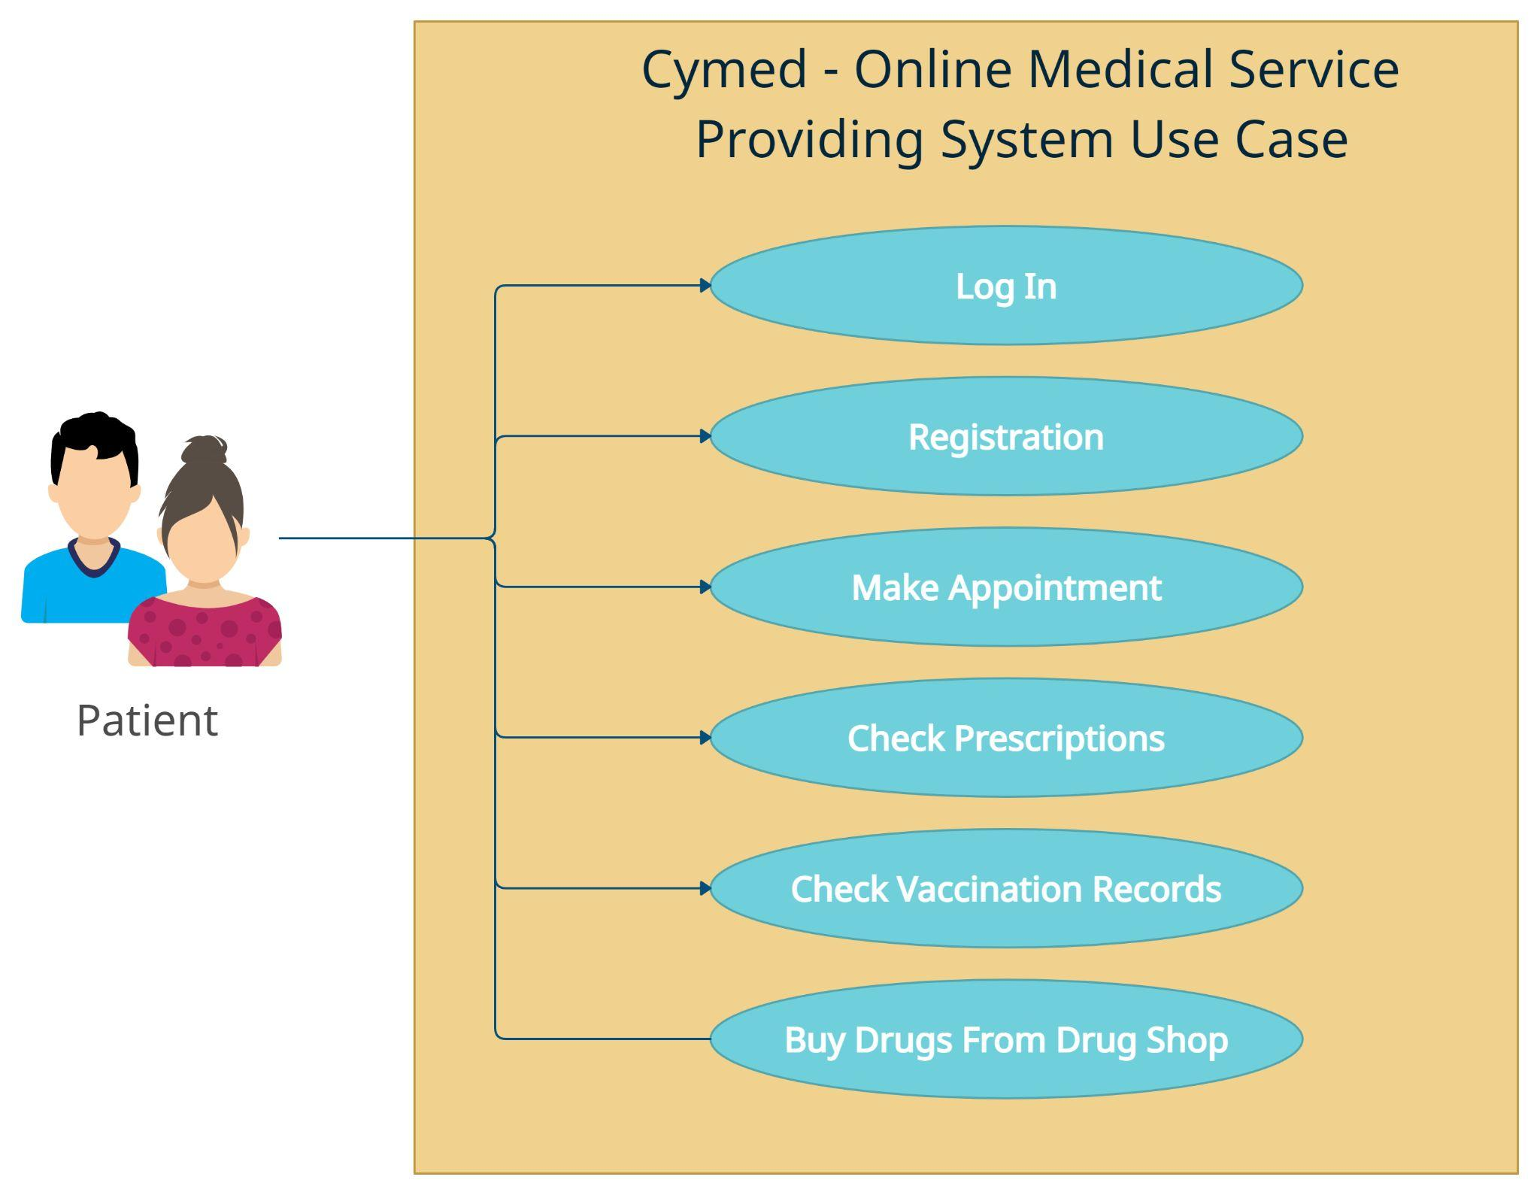

### *4.1 Registration*

Patients can register themselves into the system by simply providing several information such as name, date of birth, gender, email, and contact number. Once the registration is complete the patient will be assigned a patient ID.

### *4.2 Login*

Patients can log in to their respective accounts by entering their email and password.

### *4.3 Make Appointment*

Patients will be able to make an appointment for their checkup by selecting the medical department that they require, and the date on which they want to schedule their appointment.

### *4.4 Check Prescriptions*

Patients will be able to check their lifetime prescriptions and obtain a detailed view of the prescription that they will select.

### *4.5 Check Vaccination Records*

Patients will be able to check lifetime vaccination records and obtain a detailed view of an individual record by selecting it. They will also be able to add previous vaccination details manually by providing the vaccine name, the medical form from which they have obtained the vaccine, the vaccination date, and the name of the Doctor who assisted in the vaccination process.

### *4.6 Buy Drugs from Drug Shop*

Patients will be able to purchase the prescribed or necessary drugs from the inbuilt drug store directly.

5. Use-Cases (Doctor’s Panel)

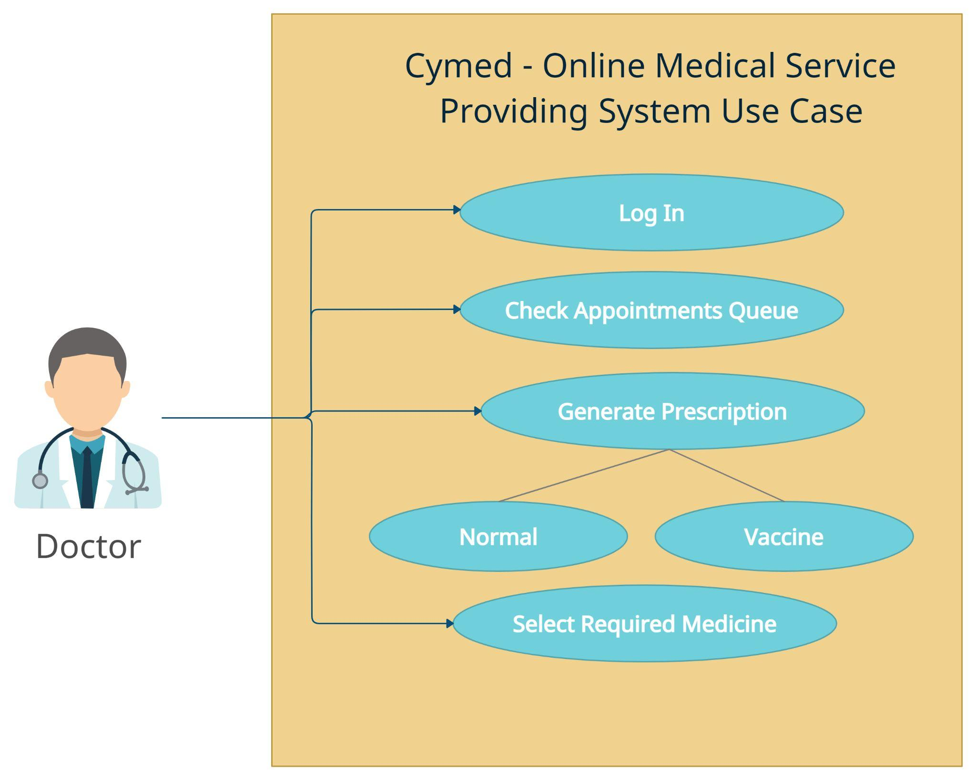

### *5.1 Login*

Doctors will be able to login into their account by simply entering their “initial” provided by the admin and password.

### *5.2 Check Appointments Queue*

The Doctor will be able to check his appointment queue and notify his/her patients by sending a notification SMS about their turn.

### *5.3 Generate Prescription (Normal)*

A normal prescription is for those patients who have made an appointment for an actual checkup. The Doctor can prepare a “Normal” prescription by simply mentioning the disease, and required tests, and selecting the drugs needed for treatment directly from the drug database.

### *5.4 Generate Prescription (Vaccination)*

A vaccination prescription is for those patients who will be vaccinated. The Doctor just needs to enter that vaccine name that he/she is providing to the patient, and the rest of the details will be automatically filled up (Patient’s name, Patient’s Date of Birth, Patient’s Age, Medical Name, Vaccination Date, and Doctor’s Name).

### *5.5 Select Required Drug(s)*

This option will be available within the “Generate Prescription (Normal)” use case. Doctors will be able to select the required drugs for the treatment of their patients directly from the drug database and mention the consumption timing for each drug.

6. Use-Cases (Admin’s Panel)

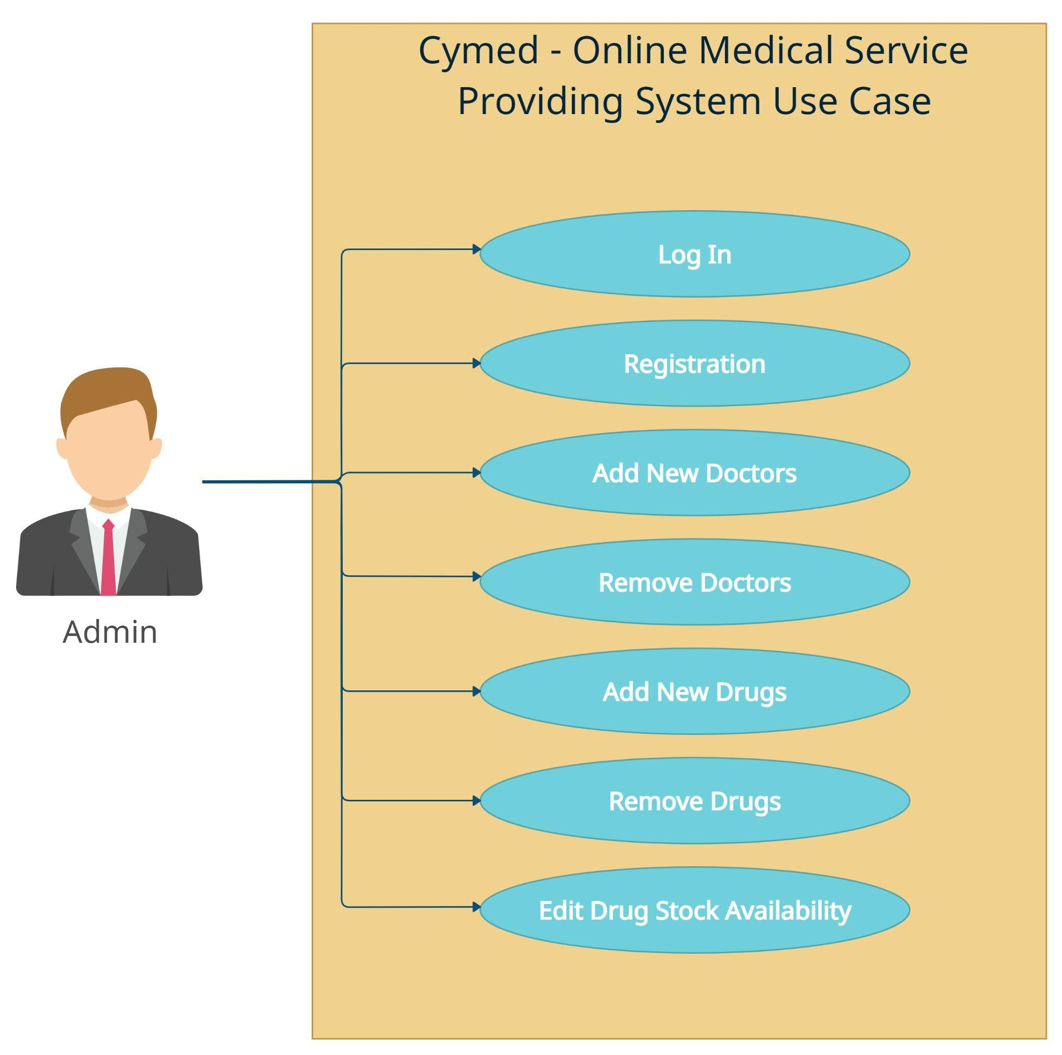

### 

### *6.1 Registration*

Admins will be able to register themselves into the system by providing their name, date of birth, gender, admin verification key held by higher authorities, email, and contact number. Once the registration is complete the system will automatically generate an admin id.

### *6.2 Login*

Admins will be able to login into their respective accounts by simply entering their “admin id” and password.

### *6.3 Add New Doctor*

Admins will be able to register new Doctors into the system, by entering the Doctor’s details like name, gender, date of birth, occupation, email, contact number, medical department, working days, and “initial” provided by the authority.

### *6.4 Remove Doctor*

Admins will be able to remove a doctor from the system.

### *6.5 Add New Drug*

Admins will be able to add new drugs to the drug database. The required fields for a drug registration include Drug Name, Drug Image, Drug Description, Drug Dosage, and Drug Price.

### *6.6 Remove Drug*

Admins will have the capability to remove a particular drug from the drug database.

### *6.7 Edit Drug Stock Availability*

Drug Stock details will be automatically updated on every purchase, however, if new stocks arrive the available stock size needs to change. In that case, admins will also be able to change the stock size of a particular drug by simply selecting the drug from the database and entering the new stock size.

7. Software

* Version Control System - Git
* Repository Hosting Service - Bitbucket
* Integrated Development Environment IDE - VS Code
* Web-Server (SQL Database XAMPP)
* Infinity Free or Heroku (Deployment)
* Google Docs (Report)
* Microsoft Office (Report)
* Creately (Diagrams)

8. Technologies

* HTML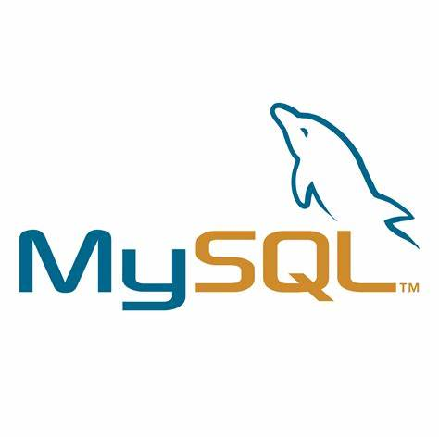
* CSS
* Bootstrap
* JavaScript
* jQuery
* PHP
* MySQL

9. Front-End Plan

1. Main Page
2. Profile (Patient Panel, Doctor Panel, Admin Panel)
3. Check Prescriptions Records
4. Vaccination Records
5. Drug Shop Design
6. Check Appointment Queue

10. Back-End Plan

1. *DB Plan Design and Development (MySQL)*
2. *Account Creation*
   1. Registration Form (Patient Panel, Doctor Panel, and Admin Panel)
   2. Login (Patient Panel, Doctor Panel, and Admin Panel)
3. *Task Management*
   1. Make Appointment
   2. Generate Prescription (Normal and Vaccination)
   3. Select Required Drugs from Database
   4. Add or Remove Doctors
   5. Add or Remove Drugs
   6. Edit Drug Stock Availability
4. *Searching Facility*
   1. Search drugs in Drug Shop
   2. Select Required drugs for prescription
5. *Payment Gateway*
   1. PayPal Payment API Integration
   2. VISA payment API Integration
   3. Payment option for drug purchase
6. *Shopping Cart or Product List to be ordered*
7. *Automation*
   1. SMS Notification for the patient by doctor
   2. On Appointment Date Notification
   3. Automatic ID generator during registration

11. Development Plan

*Phase 1:* In this phase, we will be focusing on the total functioning of the registration and login for all the available panels. Furthermore, we will also be working on the database connections and database designs. This phase will approximately take two complete weeks.

*Phase 2*: In this phase, we will be focusing on the other functionalities of all the panels. In the first week, we will be working on the features of the Admin Panel both frontend and backend. In the second week, we will complete the Doctor Panel utilities. In the next two weeks (third and fourth), we will concentrate on the Patient Panel facilities, on some bugs, and complete testing procedures.

*Phase 3*: In this phase, we will focus on the deployment of the complete system onto an online free hosting service like “Infinity Free” or “Heroku”.

12. Project Schedule (Gantt Chart)

